Study of Active Queue Management Using OPNET

Bing Zheng Mohammed Atiquzzaman
Dept. Electrical and Computer Eng. School of Computer Science
University of Dayton University of Oklahoma
Dayton, OH 45469 Norman, OK 73019
Email: zhengbin@ieee.org Email: atiq@ou.edu

Abstract
Improving the quality of service (QoS) of Internet traffic is widely recognized as a critical issue for next-generation networks. To address this issue, we are using OPNET to help us to conceive, develop, and test new schemes, models, and algorithms for improving the performance of active queue management. Different proposed schemes, models, and algorithms are implemented in OPNET, and are evaluated by simulations. This paper presented our works in proposing new active queue management scheme and the simulation evaluation in heterogeneous network environment. The simulated results will enable us to validate different active queue management schemes and algorithms, in order to gain valuable insights for developing and deploying active buffer management schemes in next-generation networks.

Introduction
Today's Internet is moving toward providing quality capable service to increasing traffic volume with multiple traffic types such as ftp, email, http, video, voice, etc. Each different traffic type requires its corresponding quality of service (QoS). For example, interactive video requires low delay/jitter transmission, while ftp cares about packet loss. To achieve these goals, the Internet Engineer Task Force recommended the deployment of active queue management in an Internet router [1]. Today, several models of the Internet router with active queue management capable are commercially available [2].

Queue management is defined as the algorithms that manage the length of packet queues by dropping packets when necessary or appropriate. From the point of dropping packets, queue management can be classified into two categories. The first category is passive queue management (PQM) which does not employ preventive packet drop before the router buffer gets full or reached a specified value. The second category is active queue

management (AQM) which employs preventive packet drop before the router buffer gets full. Passive queue
management (for example, tail drop) is currently widely deployed in Internet routers. It has been found to
introduce several problems (for example global synchronization) in the Internet. Active queue
management is expected to eliminate global synchronization and improve quality of service (QoS)
of networks. The expected advantages of active queue management are increase in throughput, reduced delay, and avoiding lock-out. Random Early Detection (RED), an active queue management scheme, has been recommended by the Internet Engineering Task Force (IETF) as a default active queue management scheme for next generation networks. The original RED algorithm has a number of problems that led to the development of several variants of RED, which have improved the performance of RED.

The main goals of the paper are 1). to describe our approaches for performance evaluation for active queue management with OPNET;2).to compare performance for our proposed AQM scheme with RED.

The paper is organized as follows. In section II, we give insight overview of RED. Section III describes OPNET implementation and simulation topology. Section IV gives an overview of our scheme. Section V gives performance comparisons with RED by simulation. Conclusions are presented in section VI.

Overview of Random Early Detection(RED)
The basic idea behind RED[3] is that a router detects congestion early by computing the average queue length
AVG and sets two buffer thresholds MAX_THRESHOLD and MIN_THRESHOLD for packet drop as shown in Figure 1. The average queue length at time t, defined as AVG(t)=(1-w)AVG(t-1)+wq(t), is used as a control variable to perform active packet drop. AVG(t) is the new value of the average queue length at time t, q(t) is instantaneous queue length at time t, and W is a weight parameter in calculating average queue length. Normally, w is much less than one. The packet drop probability p is calculated by
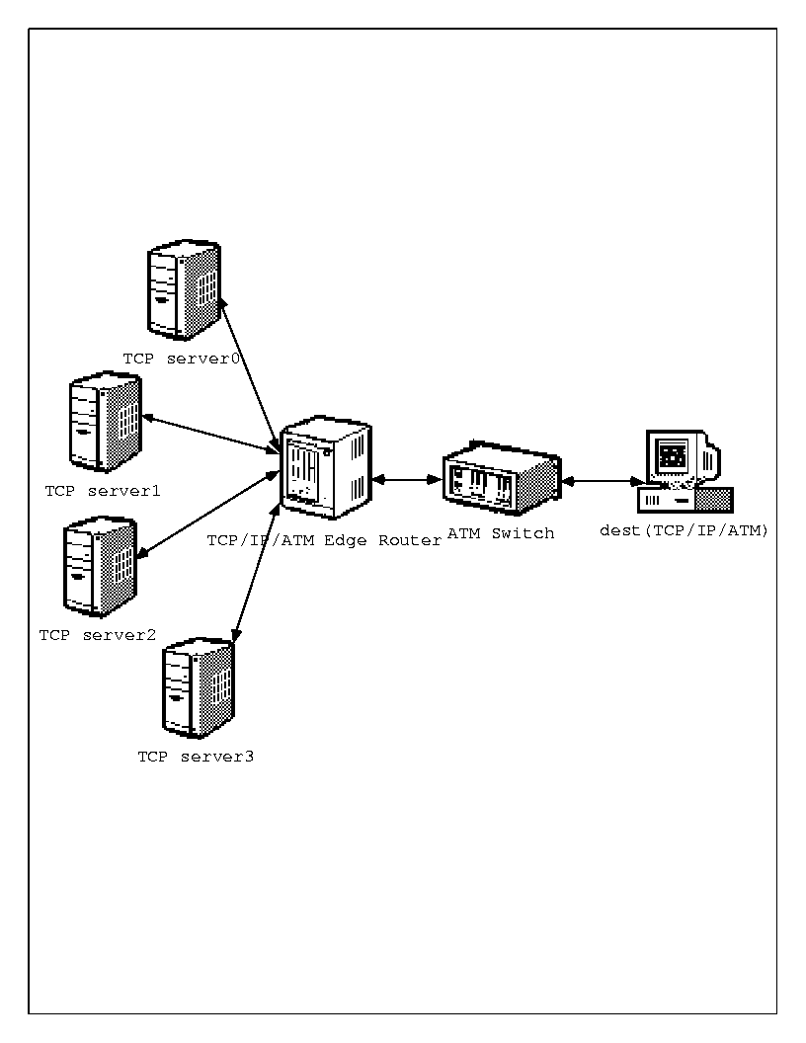
p=Pmax(AVG-MIN_THRESHOLD)/(MAX_THRESHOLD-MIN_THRESHOLD). The RED algorithm therefore, includes two computational parts: computation of the average queue length and calculation of the drop probability.

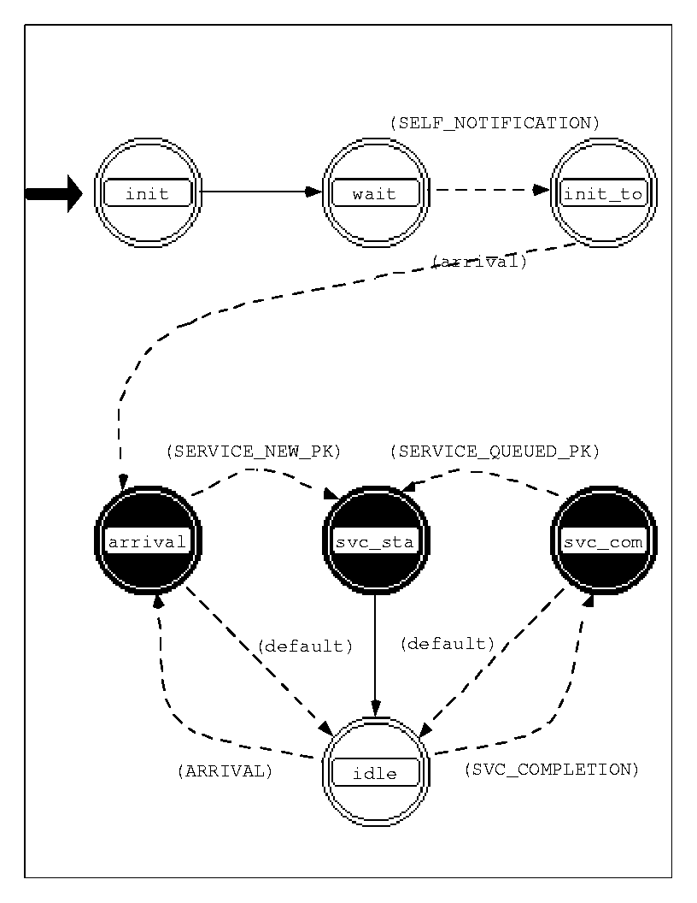
The RED algorithm involves four parameters to regulate its performance. MIN_THRESHOLD and MAX_THRESHOLD are the thresholds for average queue length to perform packet drop, Pmax is the packet drop probability at MAX_THRESHOLD, and w is the weight parameter to calculate the average queue length from the instantaneous queue size. The average queue length follows the instantaneous queue length. However, since w is much less than one, AVG changes much slower than q(t). Therefore, AVG follows the long-term changes of q(t), recording the traffic history and reflecting persistent congestion in networks. By making the packet drop probability as a function of the level of congestion, RED gateway has a low packet drop probability during low congestion, while the drop probability increases as the congestion level increases. The packet drop probability of RED is small in the interval MIN_THRESHOLD and MAX_THRESHOLD. RED gateway targets to limit the long-term average queue length between these two thresholds. Moreover, the packets to be dropped are chosen randomly from the arriving packets from different hosts. As a result, packets coming from different hosts will not be dropped simultaneously. RED gateways therefore, avoid global synchronization by randomly dropping packets.

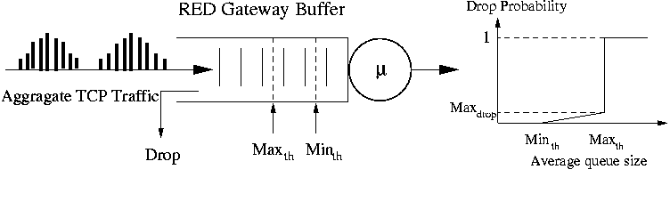
Figure.1 RED gateway model and drop function

Since the proposal of RED, lots of work have been done to evaluate its performances in throughput[4], delay/jitter[5], time response[6], traffic stability[7] etc.
It has been found that RED has problems in low throughput, large delay/jitter, poor time response, and inducing traffic oscillation. Of these problems of RED, the throughput and delay/jitter are to be discussed in this paper.

OPNET Simulation Topology and Implementation
Simulation platform is OPNET 5.1.D. Simulation
topology is shown in Figure.2, where AQM algorithm

Figure.2 Simulation topology in heterogeneous network environment

is implemented in process ip_rte_v4 that is shown in
Figure.3.

Figure.3 ip_rte_v4 process

In the initial state, a function static void get_model_parameter() gets the configuration parameters from attribute table. In the arrival state, a Boolean function Boolean packet_drop_indicator() decides the random dropping of an arriving packet based on average queue length. When an OPC_TRUE is returned, the arriving packet is dropped. The configuration parameters for the above topology are shown in Table.1. Where the aggregate traffic from server0, server1, server2, and server3 forms congested traffic. At the edge gateway, the traffic contract is assigned with ATM CBR and rt-VBR for the ATM connection between edge gateway and the destination.
Here, since we are interested in the performance concerning to aggregate traffic, the gateway is therefore set in central queue mode, i.e., traffic from different senders are queued in same subqueue.

Configuration Parameters | Value
Server0 to gateway link | Rate 100Mbps, delay 1ms
Server1 to gateway link | Rate 100Mbps, delay 3ms
Server2 to gateway link | Rate 100Mbps, delay 5ms
Server3 to gateway link | Rate 100Mbps, delay 7ms
Traffic contract at edge | ATM CBR, rt-VBR
Edge gateway to dest link | OC-1, delay 5ms

Table. 1 Configuration Parameters

Double Slope Random Early Detection (DSRED)
The new active queue management scheme tested in this paper is our proposed Double Slope Random Early Detection(DSRED)[8] as shown in Figure.4
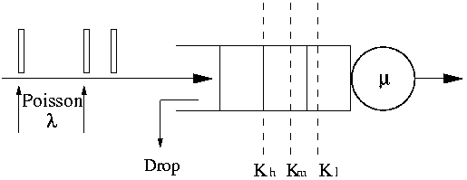
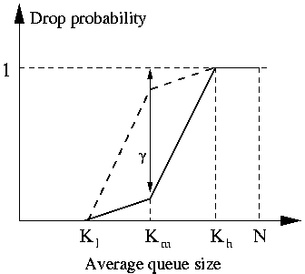

Figure. 4. DSRED gateway model and drop function

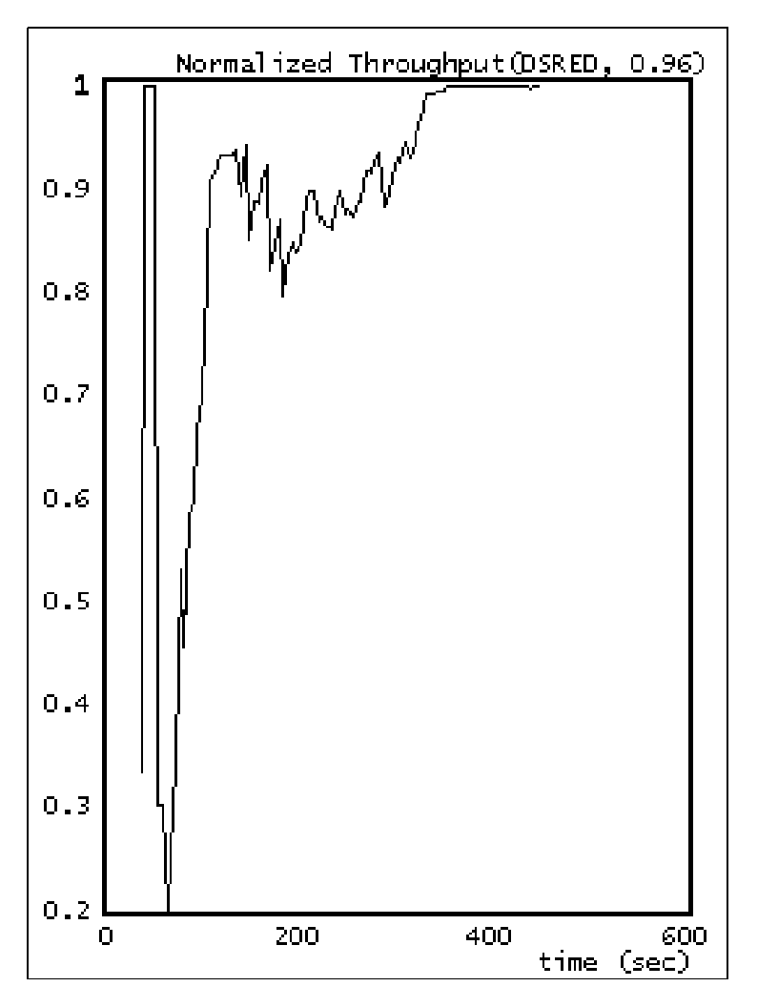It can be seen that DSRED uses a drop function whose slope adaptively changes with the congestion level. As the congestion get into heavy, DSRED will provide stronger warnings to TCP senders to slow down, in turn, the congestion will be relieved more efficiently than in RED, and queues will be forced to the lower level, resulting in lower queuing delay. In this paper, we are mainly interested in comparing the performance between DSRED and RED in TCP/IP over ATM environment with ATM CBR and rt-VBR traffic contract at TCP/IP and ATM edge gateway.

Parameter | RED | DSRED
MIN_THRESHOLD | 6 | 6
MID_THRESHOLD | N/A | 13
MAX_THRESHOLD | 20 | 20
Pmax | 0.1 | 1.0
weight | 0.05 | 0.05
γ | N/A | 0.96

Table.2 Configuration parameter for RED and DSRED

In the simulation, the recommended parameters for RED[9] are used. The configuration parameters for RED and DSRED are as in Table.2.

Simulation Results
We ran simulations for 300 seconds, that is long enough to cover the transit state of the transmissions. The CBR traffic contract at the edge gateway, the normalized throughput, queuing delay, and packet drop both for RED and DSRED are shown as follows. The normalized throughput is defined as the ratio of total number of sent packets to the total number of received packets during a period. Its insight meaning is that the probability of a packet is delivered to the destination without being dropped at gateway at a given time.
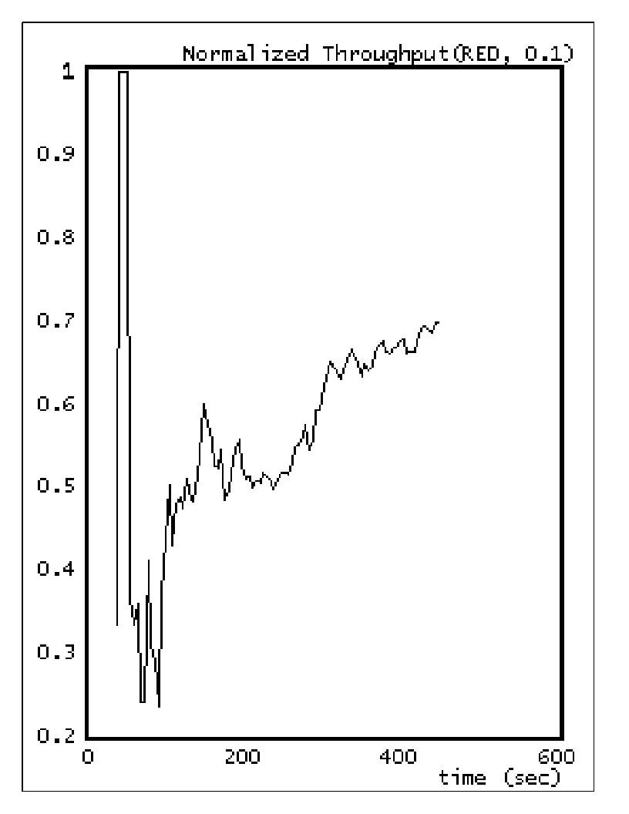
Figure.5. Normalized throughput for RED(CBR traffic contract at edge gateway).

Figure.6. Normalized throughput for DSRED(CBR traffic contract at edge gateway).

From Figure.5 and Figure.6, it can be seen that at the beginning, the TCP senders start sending there is no congestion happening, therefore, the packet is going to be delivered without drop. However, when more and more packet are injected into network, congestion happens, the gateway queue builds up quickly, and the gateway starts dropping packets by active queue management, as shown in Figure.7.
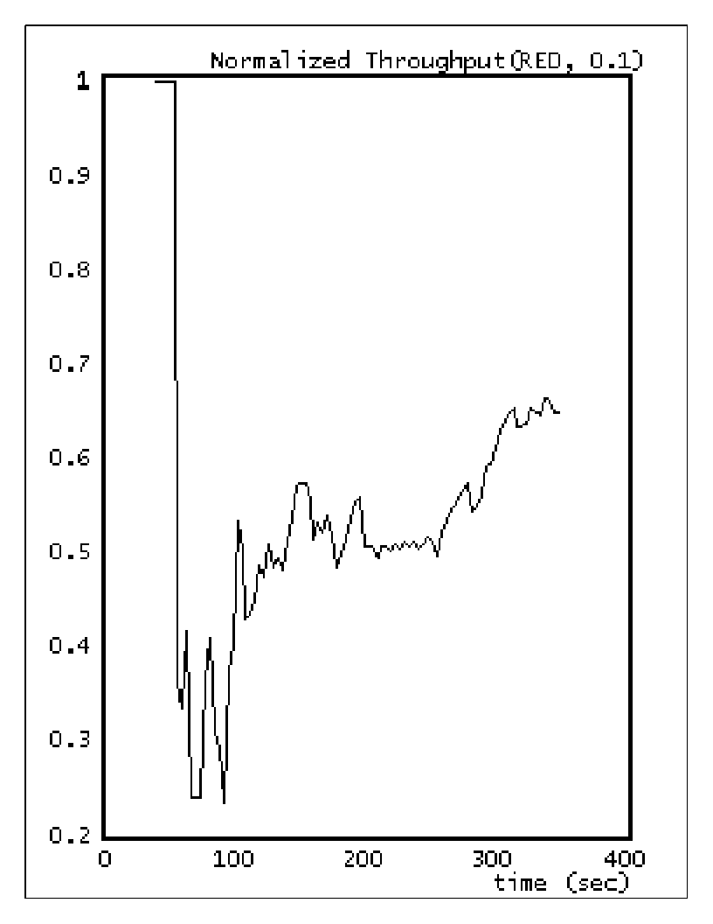
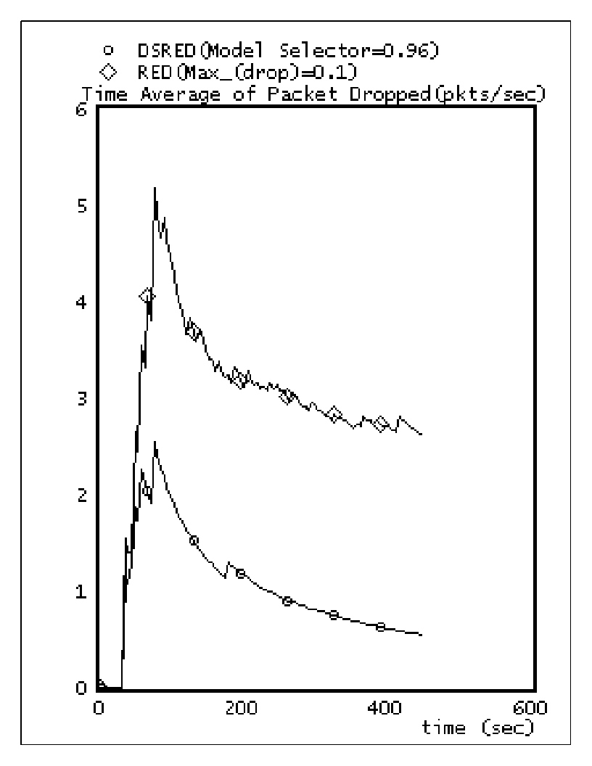
Figure.7 Packet drop at edge gateway implemented with RED and DSRED schemes(CBR traffic contract at edge gateway).

From Figure.7, since DSRED has less packet drop than RED, DSRED has higher normalized throughput than RED, as shown in Figure.5 and Figure.6. From the operating mechanism of RED and DSRED, less packet drop means the small value of long term queue size, or smaller value of long term queuing delay at edge gateway, this is verified by Figure.8.
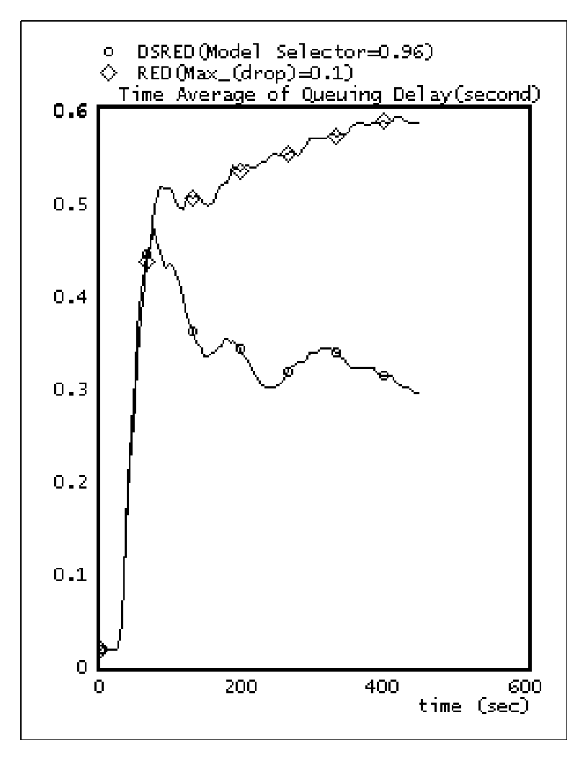
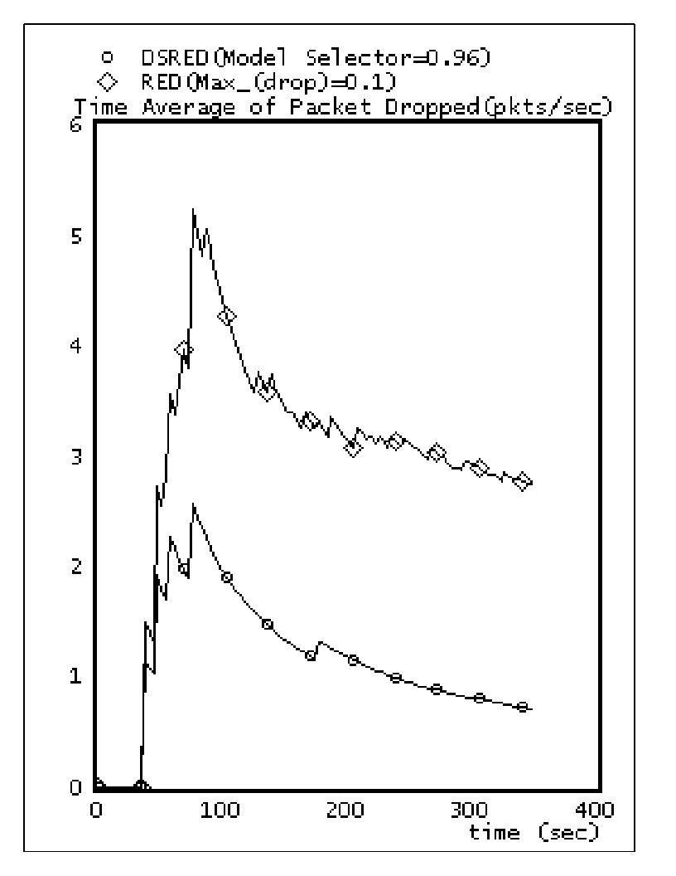

Figure.8 Queuing delay at edge gateway for RED and DSRED(CBR traffic contract at edge gateway).

We also ran simulations for rt-VBR contract at the edge gateway to study the performance both for RED and our

Figure. 9 Normalized throughput for RED(rt-VBR traffic contract at edge gateway).
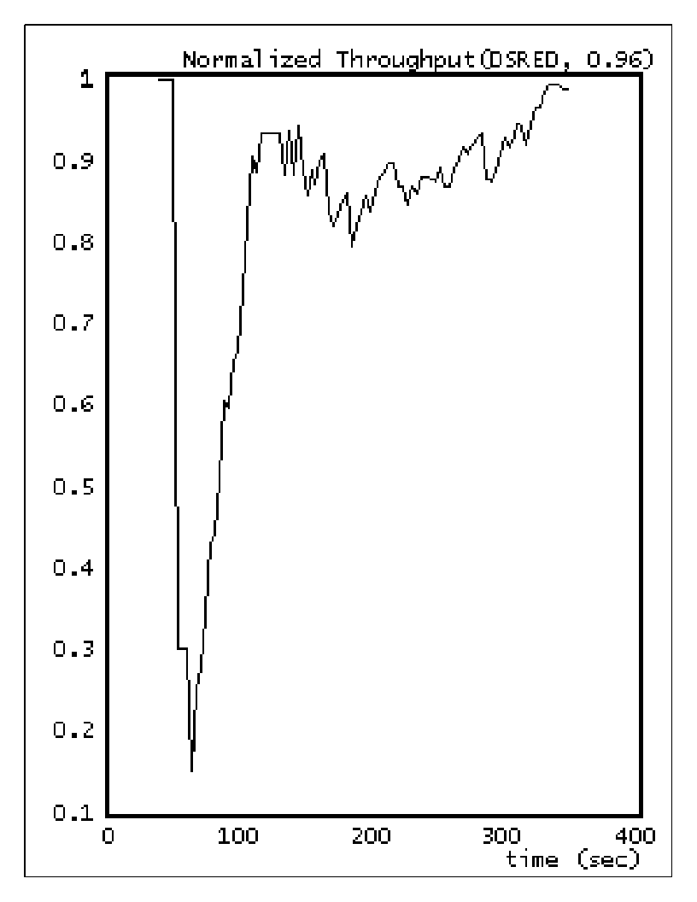
Figure.10 Normalized throughput for DSRED(rt-VBR traffic contract at edge gateway).

Figure.11 Packet drop at edge gateway(rt-VBR traffic contract at edge gateway).

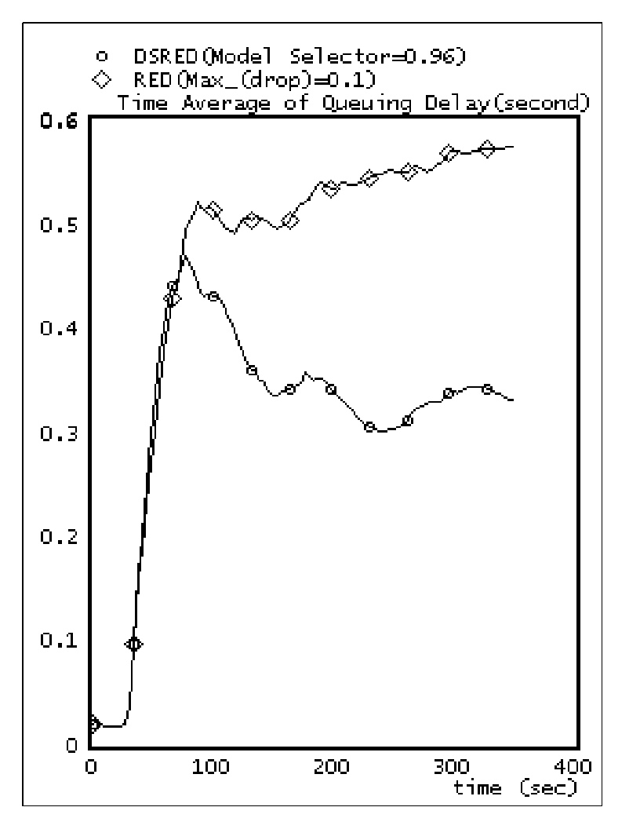
DSRED scheme to see the robust of the schemes for different traffic contract. The simulated normalized throughput, packet drop, and queuing delay performance as shown in Figure.9, Figure.10, Figure.11, and Figure.12.

Figure.12 Queuing delay for RED and DSRED at edge gateway(rt-VBR traffic contract at edge gateway).

It can be seen that both RED and DSRED are robust for different traffic contract at edge gateway, i.e., their performance keeps similar for different traffic contract. This feature is important because today's network is going to deliver different traffic that may require different link features. It also can be seen that in all of the traffic contract cases, DSRED always outperforms RED in terms of normalized throughput, packet drop, and queuing delay. From above figures, we get Table.3 to give comparison and summary. Where the long term refers the end of simulation.

Performance | RED | DSRED
Normalized throughput | 0.65 | 0.98
Long term packet drop rate | 3 pkts/sec | 1 pkts/sec
Peak packet drop rate | 5 pkts/sec | 2.5 pkts/sec
Long term queuing delay | 0.56 sec | 0.35 sec

Table.3 Performance summary and comparison for RED and DSRED.

Conclusion
In this paper we presented the simulated results to compare our proposed active queue management scheme DSRED with RED in the TCP/IP over ATM network environment, especially with CBR and rt-VBR traffic contract at edge gateway. Simulation results show that our proposed DSRED scheme outperforms RED in terms of normalized throughput, queuing delay, and packet drop. Simulation results also show that performances of both DSRED and RED are robust to different traffic contract at edge gateway.

References
[1]. B.Braden, D. Clark, J. Crowcroft, B. Davie, S. Deering, D. Estrin, S. Floyd, V. Jacobson, G. M. C. Partridge, L. Peterson, K. Ramakrishnan, S. Shenker, J. Wroclawski, and L. Zhang," Recommendations on queue management and congestion avoidance in the Internet," RFC 2309, April, 1998

[2]. Cisco System, "IOS Technology," http://www.cisco.com/warp/public/732/Tech/red/
[3]. S. Floyd, V. Jacobson," Random Early Detection Gateways for Congestion Avoidance," IEEE/ACM Transaction on Networks, Vol.1, No. 4 August, 1993, pp.397-413.

[4]. B.Suter, T. V. Lakshman, D. Stiliadis, A. K. Choudhury, "Buffer Management Schemes for Supporting TCP in Gigabit Routers with Per-flow Queuing," IEEE Journal on Selected Areas in Communications, Vol.17, No.6, June, 1999, pp1159-1169.

[5]. M. May, T. Bonald, J. C. Bolot, "Analytic Evaluation of RED Performance," IEEE INFOCOM2000, Tel-Aviv, Israel, March 26-30,2000

[6]. Mikkel Christiansen, Kevin Jeffay, David Ott, F. Donelson Smith, "Tuning RED for Web Traffic," ACM SIGCOMM2000, Stockholum, Sweden, August, 2000

[7]. V. Firoiu, M. Borden, "A Study of Active Queue Management for Congestion Control," IEEE INFOCOM2000, Tel-Aviv, Israel, March 26-30,2000

[8]. Bing Zheng, Mohammed Atiquzzaman, "DSRED: An Active Queue Management Scheme for Next Generation Networks," IEEE LCN2000, Tampa, Florida, USA, November 8-10, 2000, pp242-251

[9]. S. Floyd, "RED: Discussions of Setting Parameters," http://www.aciri.org/floyd/red.html, November 1997

